**RICHARD’S MUSIC THERAPY FUND**

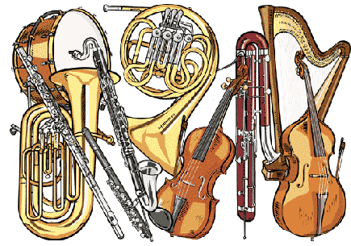 **C/o The Croft Children’s Unit**

**Ida Darwin, Fulbourn, Cambridge, CB21 5EE**

**Telephone (01223) 885800**

**Fax (01223) 885801**

**Email:** [**jo.tomlinson@cambridgeshire.gov.uk**](mailto:jo.tomlinson@cambridgeshire.gov.uk)

**Music Therapy Evaluation Form**

Richard’s Music Therapy Fund is charity funded. We are very fortunate that this is so, and we are enormously grateful to our benefactors, without whom we could not provide this service.

We are continually evaluating our music therapy service and in order to do so, we would appreciate your feedback on the sessions you have attended, with any ideas on how we could improve the service. Also, we regularly feedback to our sponsors about this work, and we would like to be able to give them some views and comments from the children and families we see.

In order to do this we have compiled a few questions below, which we would be very grateful if you could answer.

Thank you very much for your time!

Name of Child________________________________________DOB______________

Parent/Carers name_________________________________________________________

Dates of music therapy treatment (from - to)___________________________

Did you know anything about music therapy before beginning treatment at Richards Fund? If so, was it as you had expected? (Please give details)

Did you initiate your child’s referral, or was it suggested by your child’s paediatrician or another health professional?

Did you feel these music therapy sessions were helpful? (Please expand)

1. For your child?
2. For you and your family?

On a scale of 1-5 how would you rate this music therapy provision?

1 2 3 4 5

Not useful Quite useful Good Very good Excellent

During this course of therapy, were your views and concerns supported and acknowledged by the therapist? Did you feel consulted and included at all stages of the therapy? (Please expand)

Did the outcomes meet your expectations?

How could we improve this service?

Any other comments

Would you mind being contacted by us again in the future, in order for us to ascertain the possible long-term effects of music therapy?

Yes/No

If so, please provide your preferred means of contact (NB. This information will be used solely for our music therapy service and your contact details will not be passed on).

Contact address:_______________________________________________________

Telephone number_______________________________________________

Email address__________________________________________________

Signature_____________________________Date_____________________

Thank you very much for taking the time to complete this form.

Please could you return the form to:

Dr. Jo Tomlinson

Richards Music Therapy Fund

C/o The Croft Children’s Unit

Ida Darwin

Fulbourn

Cambridge

CB21 5EE

Or email it to: jo.tomlinson@cambridgeshire.gov.uk

The information you have provided will remain confidential and will be used solely for the purposes of improving the music therapy service at Richard’s Music Therapy Fund, at The Croft Children’s Unit